


Model Training and Performance Evaluation

My Model Training and Performance Evaluation
I trained my own machine-learning models using the 22-crop dataset containing 2,200 samples and 7 input features for crop recommendation. After training, I evaluated my models using Accuracy, Precision, Recall, and F1-score to measure their performance. I then compared my model results with the results reported in previous research papers that used the same 22-crop dataset.

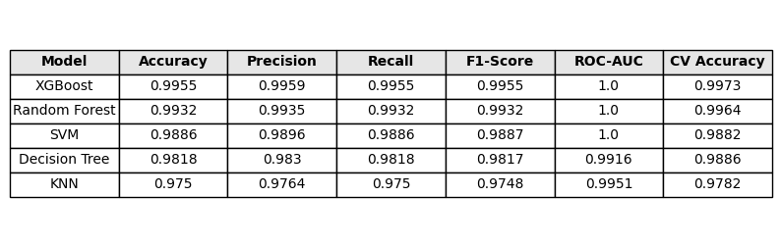

Related Research on the 22-Crop Dataset

Research Papers Using the 22-Crop Dataset
The following are research papers that use the 22-crop dataset for crop recommendation. Many researchers have worked with this dataset, but only five relevant research papers are included here. These papers were selected because they report Accuracy, Precision, Recall, and F1-score for different machine-learning models, making them useful for comparing their results with our model.

Comparison of Results from Previous Research
The following are the results of different machine-learning models reported in research papers that use the 22-crop dataset. These results show how different models perform on the same or similar dataset and provide a useful benchmark for our work. By comparing these results, we can evaluate our model’s Accuracy, Precision, Recall, and F1-score against previous studies. This comparison also helps us understand which machine-learning models perform well for crop recommendation. Therefore, these previous studies provide a strong reason for selecting the 22-crop dataset for our research and evaluating our own model on it.

1. Research Paper[Research Paper Link]
This research paper presents a crop recommendation platform using machine learning. The researchers preprocess crop, soil, and environmental data, train different classification models, and select the best-performing model for recommending suitable crops.
Dataset Used[Dataset Link]
The researchers used the Crop Recommendation Dataset with 2,200 records and 22 crop classes. It contains 7 input features: N, P, K, temperature, humidity, pH, and rainfall, with the crop name as the target label.
Models Used
The researchers tested KNN, Decision Tree, Random Forest, XGBoost, and SVM models. They compared the models and selected the best-performing model for their crop recommendation platform.
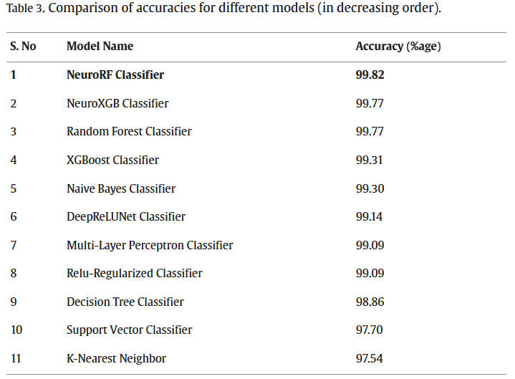

Results
The study evaluated the models using classification performance metrics and deployed the best-performing model as a cloud-based web application for crop recommendation.

2. Research Paper [Research paper link]
This research paper presents a machine-learning-based crop recommendation system. The study uses soil and environmental parameters to recommend suitable crops and compares different machine-learning models.

Dataset Used[Dataset Link]
The researchers used the Kaggle Crop Recommendation Dataset, which contains 22 different crop classes. The dataset includes N, P, K, temperature, humidity, pH, and rainfall as input features.

Models Used
The researchers used Decision Tree, AdaBoost, K-Nearest Neighbors (KNN), Random Forest, and Support Vector Machine (SVM) models. The best-performing model was AdaBoost with Decision Tree, with about 98% accuracy.

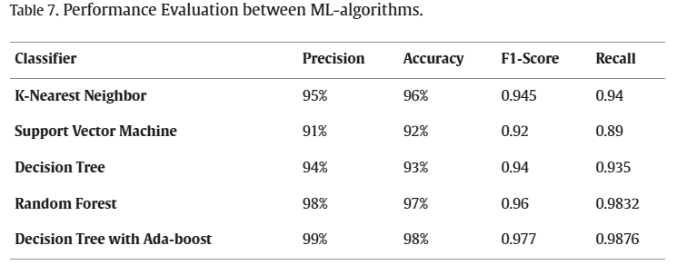

Results
The best model achieved approximately 98% accuracy. You can add your own Accuracy, Precision, Recall, and F1-score beside the paper's results to compare your model with this research.

3. Research Paper [Research Paper Link]
This research paper develops a crop recommendation system using machine learning. The study compares seven supervised ML models to find which model performs best for recommending crops from soil and climate conditions.
Dataset Used[Dataset Link]
The researchers used a publicly available Crop Recommendation Dataset containing 2,200 samples and 22 crop classes, with 100 samples for each crop. The dataset has 7 features: N, P, K, temperature, humidity, pH, and rainfall.
Models Used
The researchers tested Logistic Regression, KNN, Gaussian Naive Bayes, Decision Tree, SVM, Random Forest, and Gradient Boosting. Random Forest and Gaussian Naive Bayes achieved the best test accuracy of 99.45%.
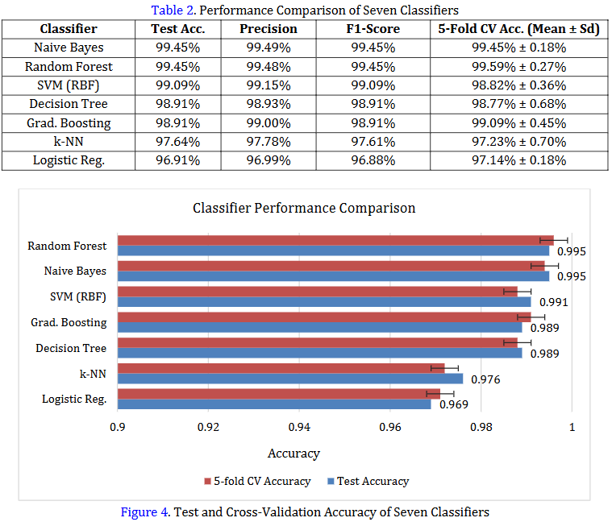

Results
Random Forest achieved 99.45% Accuracy, 99.48% Precision, and 99.45% F1-score, while its 5-fold cross-validation accuracy was 99.59%.
4. Research Paper[Research Paper Link]
This research paper presents AgriGrow Analytics, an intelligent agriculture system that combines crop recommendation, crop health prediction, yield forecasting, and plant disease detection. For crop recommendation, the researchers compared several machine-learning models using soil and environmental data.
Dataset Used[Dataset Link]
The researchers used a 2,200-record dataset with 22 crop classes, containing N, P, K, temperature, humidity, pH, and rainfall as input features. The data was divided into 80% training and 20% testing.
Models Used
The researchers tested Decision Tree, Gaussian Naive Bayes, SVM, Logistic Regression, Random Forest, XGBoost, and KNN. Random Forest achieved the highest accuracy of 99.55% for crop recommendation.
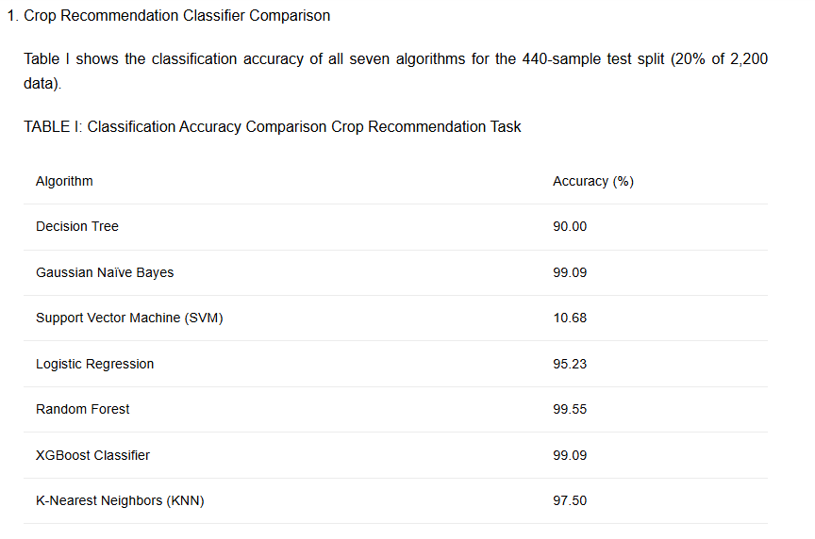

Results
The Random Forest model achieved 99.55% accuracy and performed best among the seven tested classification models. The paper also reports that the model showed high accuracy across the 22 crop classes.

5. Research Paper[Research Paper Link]
This research paper presents a crop recommendation system using supervised machine learning and Explainable AI (XAI). The researchers compared 10 ML algorithms and used Gradient Boosting as the best model for recommending crops.
Dataset Used[Dataset Link]
The researchers used the Kaggle Crop Recommendation Dataset, containing 2,200 samples, 22 crop classes, and 8 columns (7 input features + crop label). The features are N, P, K, temperature, humidity, pH, and rainfall.
Models Used
The researchers tested 10 machine-learning models, and Gradient Boosting performed the best. They also applied LIME (Explainable AI) to explain the model's crop predictions.
